ESTIMATION OF BUSINESS EXPENSES

INTRODUCTION:

* 1. **Overview**

This involves estimating all the expenses required to start and operate the business, such as equipment, rent, inventory, and marketing. By calculating these costs upfront, business owners can better plan their budget and avoid unexpected expenses. Estimating business expenses is an important step in determining how much money you need to start and keep your business running without encountering cash flow problems.

* 1. **Purpose**

Estimates are documents that provide approximate costs for a project. It is an informal document usually used during the initial stages of sales. It is also a way to agree or negotiate on the price and scope of work before it commences. I t is also known by the names such as cost estimates or proforma invoices or bids. Estimates are documents that provide approximate costs for a project. Small businesses create them for potential clients so both parties before it starts. FreshBooks has an estimates feature that help you build an estimate quickly and easily.

An estimate helps build solid client relationships. An estimate includes all projects details and makes sure you agree on everything from completion dates to prices. If you and the client are on th

PROBLEM DEFINITION & DESIGN THINKING

**2.1 EMPATHY MAP**

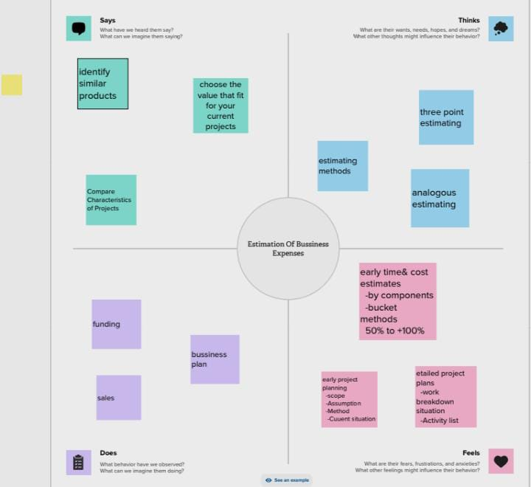

**2.2 IDEATION AND BRAINSTORMING MAP**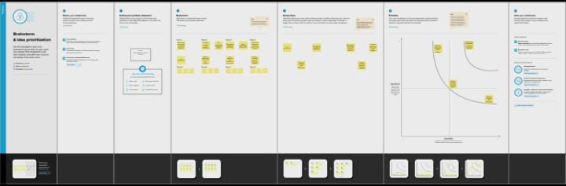

RESULT: 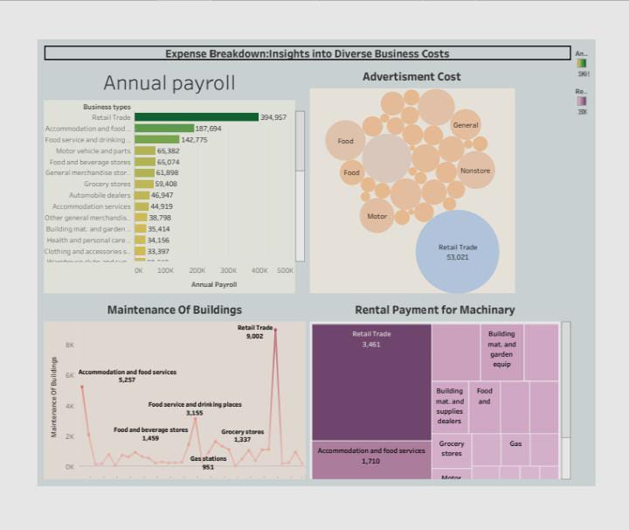

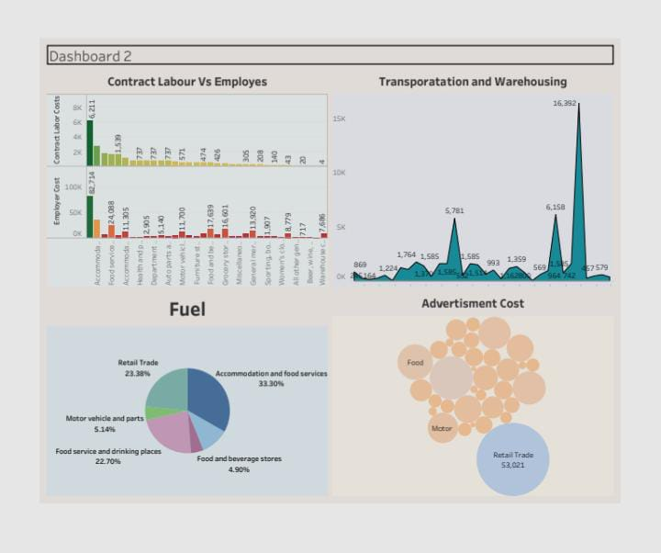

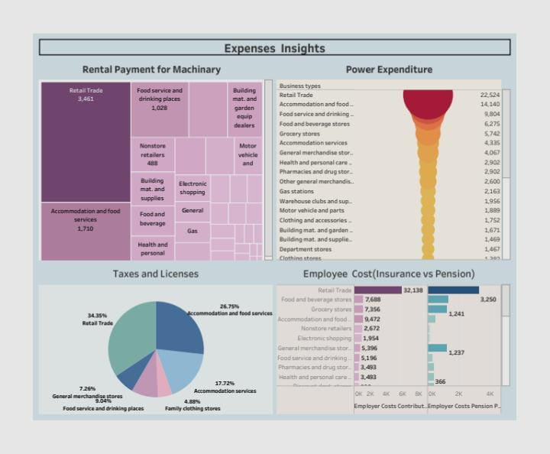

* Business expenses are incurred as part of a company’s operations.
* Business subtract their expenses from their revenue to determine their net profit or loss and taxable income.
* An expense must be considered as ordinary and necessary by the IRS to be tax-deductible.
* Business expenses are costs associated with running a company.
* Costs are subtracted from revenue to determine a company’s taxable income.

## **STORY 1**

**1.ANNUAL PAY ROLL**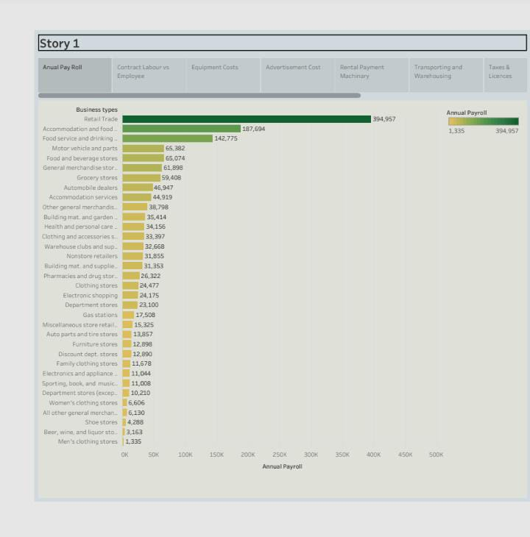

Calculating actual employee cost is a critical factor for making sound finanacial decisions, no matter your company size .

**2.CONTRACT LABOUR VS EMPLOYEE:**

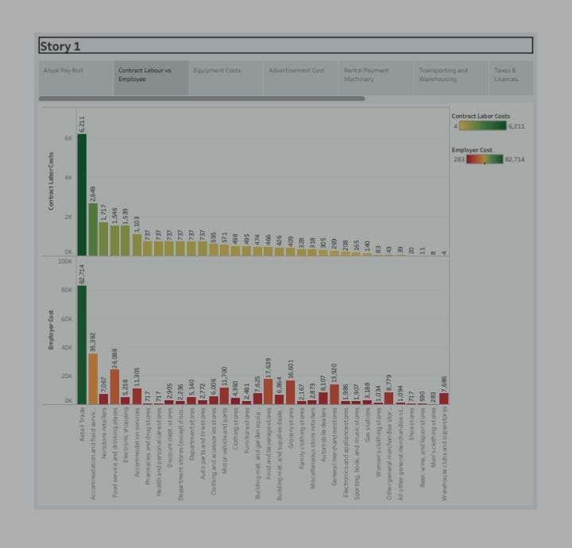

Employes cost comprises several factors, such as employes salary, payroll taxes, supplemental benefits.

**3. EQUIPMENT COSTS:**

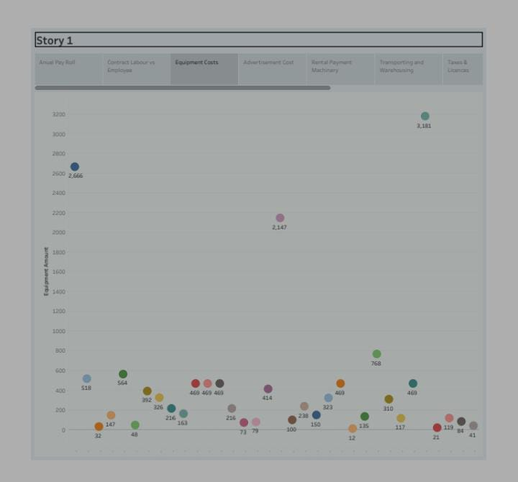

Business expenses are ordinary and necessary costs incurred to operate your bussines.

**4. ADVERTISMENT COSTS:**

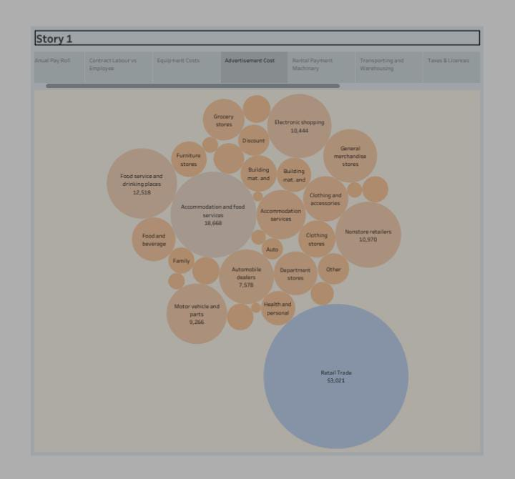

Fixed expenses are regular and don’t change much things like rent and insurance.

**5. RENTAL PAYMENT MACHINARY:**

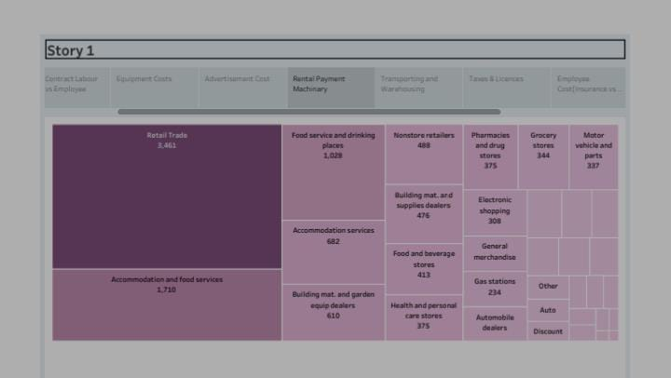

Variable expenses are expected, but they can change.

**6. TRANSPORTING AND WAREHOUSING:**

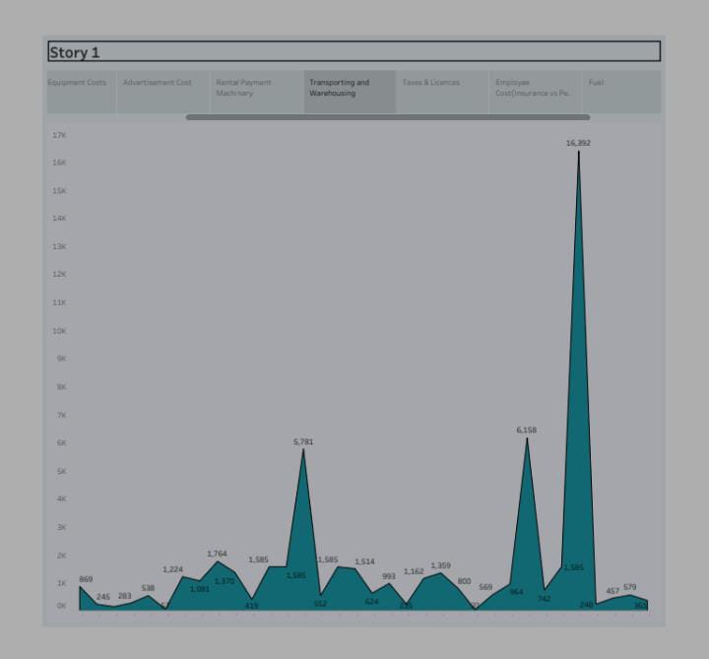

Main expense of equipment is of purchasing of equipment.

**7. TAXES AND LICENCES:**

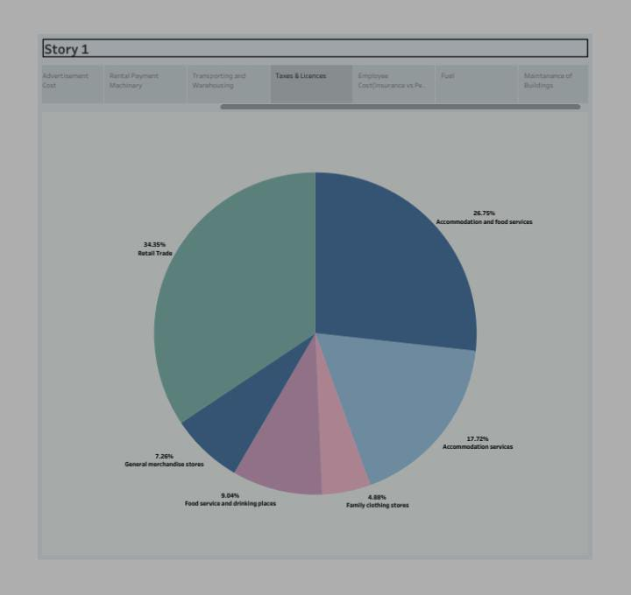

Taxes, insurance, and storage are all cost items related to owning equipment.

**8. EMPLPYEE COST :**

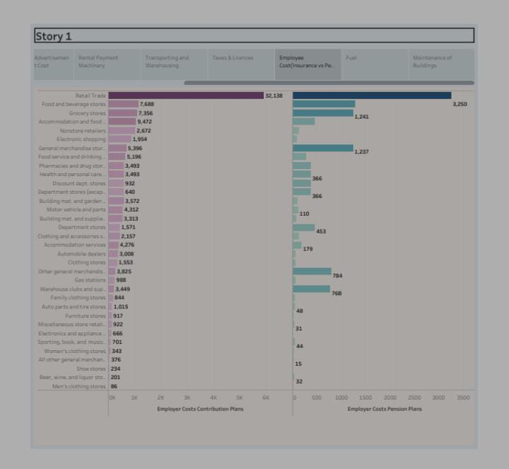

Equipment and supplies every business requires some form of equipment and basic supplies.

**9.FUELS:**

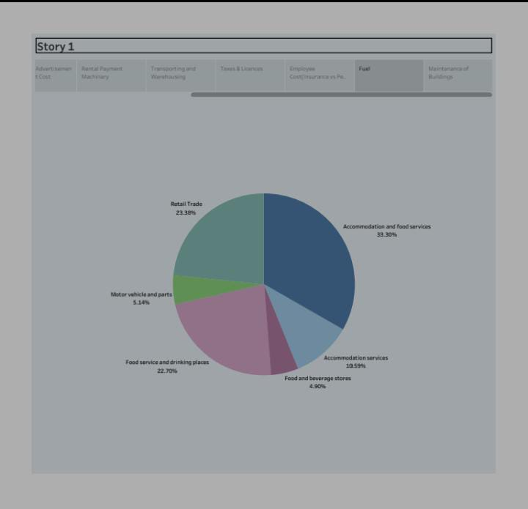 The cost equipment for a company is simply how much the company paid for the equipment.

**10. MAINTANANCE OF BUILDINGS:**

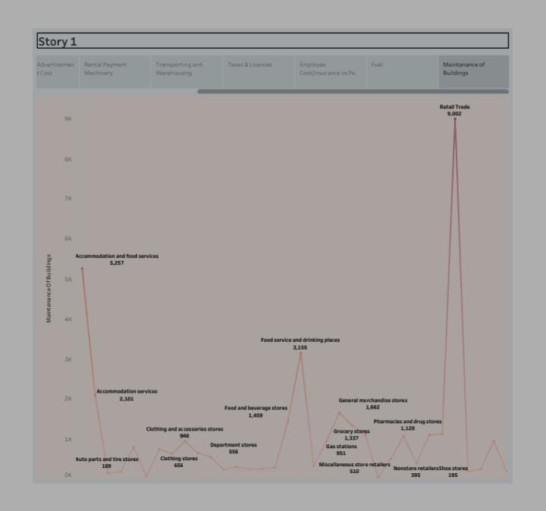

The machine Rate is usually, but not always, divided into fixed costs and operating cost.

**ADVANTAGES:**

* Cost estimation is an indispensable process that provides numerous benefits to project management.
* These benefits include budget planning, resource allocation, risk management, improved decision-making, and competitive advantages.
* An estimated cost is an approximated projection of future expenses incurred in goods production or completion of the project.

**DISADVANTAGES:**

* Lacking knowledge and experience in cost estimating can lead to inaccurate, incomplete, or unrealistic cost estimates for your projects.
* This can endanger the success of your project.
* Some of the consequences of poor cost estimating are: Schedule delays resulting from not having enough resources.

**APPLICATIONS:**

* Cost estimation helps you determine your project’s budget, schedule the work necessary and manage new resources.
* Cost estimates are also very crucial when it comes to winning new business.
* Property owners also use cost estimates to assess the feasibility of their projects before embarking on actual construction.

**CONCLUSION:**

* In conclusion, cost estimation is an important component of project management that ensures projects are finished on schedule and within budget.
* Since inaccurate cost estimate can have serious financial consequences for businesses, accurate cost estimating is crucial for all stakeholders engaged in a project.

**FUTURE SCOPE:**

* Cost estimation enables you to predict the funds needed and compare the estimation with your budget.
* If the estimation exceeds your budget, you can refine your plan before starting the project.
* Cost estimation in project management is the process of forecasting the financial and other resources needed to complete a project within a defined scope.